- Create the EMPLNEW1 table with the following structure:
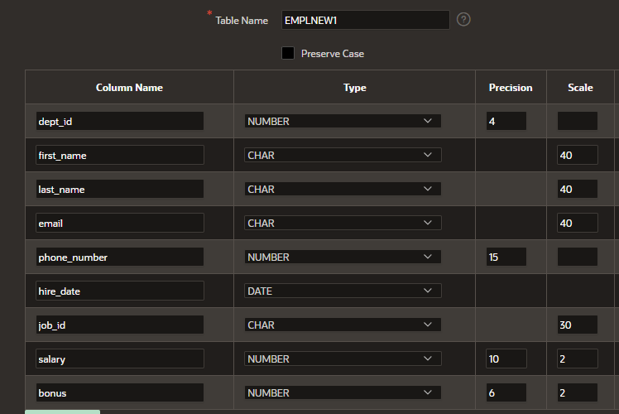

- Insert rows into the table created based on the following table:
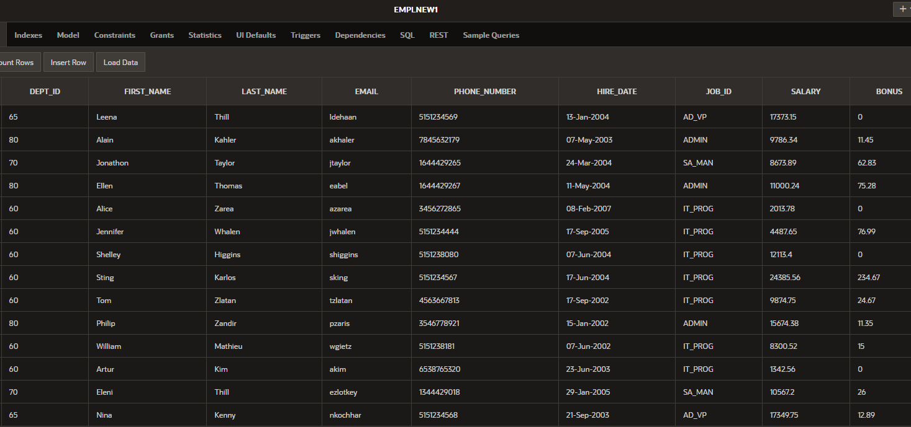

For all the following questions use EMPLNEW1 table:
- Display all the information about the employees.
SELECT *
FROM EMPLNEW1

- Display the last_name and the first_name with uppercase letters in one column.
SELECT upper(last_name) || '' || upper(first_name)
FROM EMPLNEW1

- Display the sum of the salary for employees having job_id= IT_PROG or ADMIN.
SELECT sum(salary)
FROM EMPLNEW1
WHERE job_id in ('IT_PROG', 'ADMIN')

- Increase the salary of employees by 5% and display the last_name, the first_name the salary, and the new salary.
SELECT last_name, first_name, salary, salary+salary*0.05
FROM EMPLNEW1

- Increase the salary of employees by bonus and display all the information.
SELECT DEPT_ID, FIRST_NAME, LAST_NAME, EMAIL, PHONE_NUMBER, HIRE_DATE, JOB_ID, SALARY+Bonus, BONUS
FROM EMPLNEW1

6. Decrease the salary of employees by 7% and display the last_name, the first_name the salary, and the new salary. Use an alias(NEW_SALARY) to display the new salary.
SELECT last_name, first_name, salary, salary-salary-0.07 as "New Salary"
FROM EMPLNEW1

7. Display all the information about the employees having job_id “IT_PROG” and the
salary<15000.
SELECT *
FROM EMPLNEW1
WHERE job_id ='IT_PROG' and salary<15000

8. Display the average of the salary for employees having job_id= IT_PROG.
SELECT avg(salary)
FROM EMPLNEW1
WHERE job_id ='IT_PROG'

9. Display all the information for employees having job_id=IT_PROG and arrange in
descending order according to salary.
SELECT *
FROM EMPLNEW1
WHERE job_id ='IT_PROG'
order by salary DESC

10.Display the first_name and the last_name in uppercase in a new column „New”,
and the dept_id for employees having dept_id=60 or 80(two methods).
SELECT upper(last_name) || '' || upper(first_name) as "New", dept_id
FROM EMPLNEW1
WHERE dept_id in (60, 80)

SELECT upper(last_name) || '' || upper(first_name) as "New", dept_id
FROM EMPLNEW1
WHERE dept_id=60 or dept_id=80

11.Display the first_name, the last_name the salary and the dept_id for employees
having dept_id >65.
SELECT first_name, last_name, salary, dept_id
FROM EMPLNEW1
WHERE dept_id >65

12.Display the last names of all employees who have “o” or “a” in their last names.
SELECT last_name
FROM EMPLNEW1
WHERE last_name like '%o%' or last_name like '%a%'

13.Display all employees whose last names start with “K” or „Z”. Arrange in order
according to salary.
SELECT last_name
FROM EMPLNEW1
WHERE last_name like 'K%' or last_name like 'Z%'
order by salary

14.Display all the information about the employees hired after 1st January 2004.
SELECT *
FROM EMPLNEW1
WHERE hire_date>'01-Jan-2004'

15.Display the maximum of the salary for employees having job_id=AD_VP or
IT_PROG.
SELECT max(salary)
FROM EMPLNEW1
WHERE job_id in ('AD_VP', 'IT_PROG')

16.Display the average of the salary and round the result to 2 decimal places for
employees having job_id=AD_VP or IT_PROG.
SELECT round(avg(salary),2)
FROM EMPLNEW1
WHERE job_id in ('AD_VP', 'IT_PROG')

17.Display the first_name, the last_name, the dept_id and the salary for employees
having bonus. Arrange in order according to salary.
SELECT first_name, last_name, dept_id, salary
FROM EMPLNEW1
WHERE bonus!=0

18.Increase the salary of employees having job_id IT_PROG or AD_VP by 5% and
display first_name, last_name, salary and the new salary using an alias.
SELECT first_name, last_name, salary, salary+salary*0.05 as "New salary"
FROM EMPLNEW1
WHERE job_id in ('AD_VP', 'IT_PROG')

19.Decrease the salary of employees by 5% and display first_name, last_name, salary
and the new salary for employees having dept_id=70 or 80.
SELECT first_name, last_name, salary, salary-salary*0.05
FROM EMPLNEW1
WHERE dept_id in (70, 80)

20.Display all the information about the employees having salary between 10000 and
15000.
SELECT *
FROM EMPLNEW1
WHERE salary between 10000 and 15000

21.Display the email in uppercase and the job_id with small lettres in a new column
„New”.
SELECT upper(email) || lower(job_id) as "New"
FROM EMPLNEW1
22.Arrange in order according to salary and display first_name, last_name, salary.
SELECT first_name, last_name, salary
FROM EMPLNEW1
ORDER by salary

23.Display all the information about the employees having job_id=IT_PROG.
SELECT *
FROM EMPLNEW1
WHERE job_id='IT_PROG'

24.Display the last_name and the first_name in capital letters in a new column “Name”
for employees having dept_id=80.
SELECT upper(last_name) || upper(first_name) as "Name"
FROM EMPLNEW1
WHERE dept_id=80

25.Write a query to return the first character of the first name concatenated to the last_name and the salary for employees.
SELECT SUBSTR(first_name, 1, 1) ||''|| last_name, salary
FROM EMPLNEW1

26. Write a query to return the first character of the first name concatenated to the
last_name, the salary, and the dept_id for employees having dept_id=60, 65 or 70
(two methods).
SELECT SUBSTR(first_name, 1, 1) ||''|| last_name, salary, dept_id
FROM EMPLNEW1
WHERE dept_id in (60, 65, 70)

SELECT SUBSTR(first_name, 1, 1) ||''|| last_name, salary, dept_id
FROM EMPLNEW1
WHERE dept_id=60 or dept_id=65 or dept_id=70)

27. Increase the bonus for employees hired after 01.01.2005 by 10%, and display all
the information.
SELECT DEPT_ID, FIRST_NAME, LAST_NAME, EMAIL, PHONE_NUMBER, HIRE_DATE, JOB_ID, SALARY, BONUS+BONUS*0.1
FROM EMPLNEW1
WHERE hire_date>'01-Jan-2005'

28. Arrange in order according to salary and display first_name, last_name, salary.
SELECT first_name, last_name, salary
FROM EMPLNEW1
Order by salary

29. Arranging in alphabetical order all the employees (use salary) and display all the
informations for employees having dept_id= 60 or 65.
SELECT *
FROM EMPLNEW1
WHERE dept_id in (60, 65)
Order by salary

30.Arranging in descending order according to hire_date and display first_name,
last_name, salary.
SELECT first_name, last_name, salary
FROM EMPLNEW1
Order by hire_date DESC

31.Decrease the bonus of employees having job_id= IT_PROG, by 3%. Display the
first_name, the last_name, the salary, the job_id and the new bonus.
SELECT first_name, last_name, salary, job_id, bonus-bonus*0.03
FROM EMPLNEW1
WHERE job_id= 'IT_PROG'

32.Display all the information about the employees hired between January 1, 2004 and
December 31, 2005.
SELECT *
FROM EMPLNEW1
WHERE hire_date between '01-Jan-2004' and '31-Dec-2005'

33.Display the maximum of bonus for all the employees.
SELECT max(bonus)
FROM EMPLNEW1

34.Display the minimum of bonus for employees having dept_id=80.
SELECT max(bonus)
FROM EMPLNEW1
WHERE dept_id=80

35.Using a substitution variable, display the first_name, the last_name, the dept_id,
and the salary for employees having dept_id=70 or 60.
SELECT first_name, last_name, dept_id, salary
FROM EMPLNEW1
WHERE dept_id=:enter_dept_id

36.Using a substitution variable for job_id, display the first_name, the last_name, the
dept_id, and the job_id for employees having job_id=IT_PROG or ADMIN.
SELECT first_name, last_name, dept_id, job_id
FROM EMPLNEW1
WHERE job_id =:enter_job_id;

37.Using a substitution variable for dept_id, display the first_name, the last_name, the
dept_id, the hire_date and the salary for employees having department_id=80 or 50
and hired after 01.05.1998.
SELECT first_name, last_name, dept_id, hire_date, salary
FROM EMPLNEW1
WHERE dept_id =:enter_dept_id and hire_date>'01-May-1998'

38.Using a substitution variable for job_id, display the last_name, the dept_id, and the
job_id for employees having job_id=IT_PROG or ADMIN.
SELECT last_name, dept_id, job_id
FROM EMPLNEW1
WHERE job_id =:enter_job_id

39.Display the average of the salary and round the result to 2 decimal places for
employees having job_id= IT_PROG or ADMIN.
SELECT round(avg(salary),2)
FROM EMPLNEW1
WHERE job_id =:enter_job_id

40.Using a group function, display the last name in alphabetical order.
SELECT last_name
FROM EMPLNEW1
order by last_name

